This homework assignment is based on Chapter 8 (Second Look at Classes with Objects).

**There are 4 print screens/code copies, worth each 25 %**

**Project #1**

Complete the (LandTract Class) below

**#1 print screen the output with the code below here**

Note: you may use this code below as a reference:

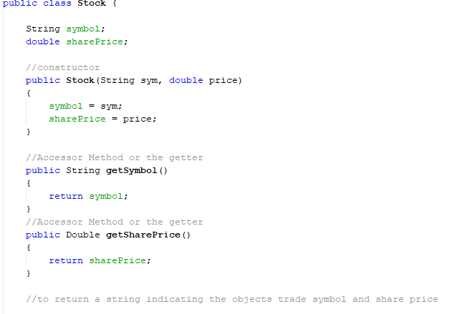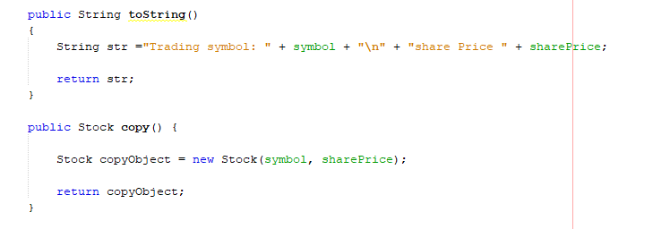

**Project #2**

Complete the (Parking Ticket Simulator) project below:

**#2 print screen the output with the code below here**

**Submit this document to Module 14 Homework**